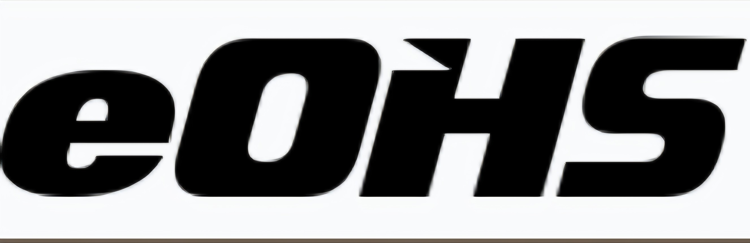

Broadway Air Extraction Protocol
Stages 3, 5 & 6
We will be working in the stages with machines that run on propane. Our goal is to ensure that everyone is working under safe conditions at all times. The maximum exposure limit of carbon monoxide (CO) under Regulation 833, on an 8-hour workday, is 25 ppm — 30 minutes at 75 ppm — while the maximum exposure limit is 125 ppm.

Ontario Occupational Health and Safety Act — Regulation 833
Control of Exposure to Biological or Chemical Agents
• Time-Weighted Average (8-hour workday): 25 ppm
• 30-Minute Exposure Limit: 75 ppm
• Maximum (Ceiling) Exposure Limit: 125 ppm

Protocol Steps
1 | Hazard Assessment — Identify atmospheric hazards, toxic fumes, or substances before commencing work.
2 | Activate LEV (Local Exhaust Ventilation) — Contact JHSC Co-Chair Richard Cimini, 647-335-4715.
3 | Air Monitoring — Continuous monitoring and testing of air quality to ensure exposure limits are not exceeded.

When working with machines or any other atmospheric hazards in the studio, please notify your JHSC Co-Chair (Richard Cimini) and the extractor will be made active in your stage. In addition to LEV, your health and safety representative will also be informed that air quality in that specific work area must be monitored.

Health Effects of Carbon Monoxide
CO — Carbon Monoxide Health Effects by Exposure Time
Exposure (hours) | Perceptible | Sickness³⁾ | Deadly⁴⁾
0.5 | 600 | 1000 | 2000
1 | 200 | 600 | 1600
2 | 100 | 300 | 1000
4 | 50 | 150 | 400
6 | 25 | 120 | 200
8 | 25²⁾ | 100 | 150

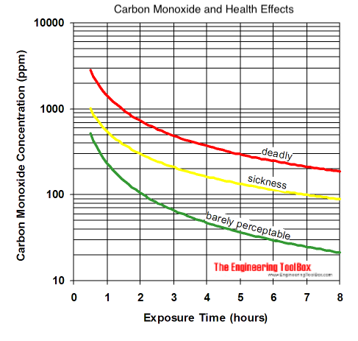
Source: The Engineering ToolBox

